STAT301 Homework 10 Name
- Use the otter-mandible data on d2l. The otter-mandible data recorded four species of otter and their mandible ramus width, mandible ramus height, moment arm temporalis, outlever at carnassal, moment arm masseter, and jaw length in cm. The data and the following figures were retrieved from Introduction to Multivariate Statistics in R by Jeff Oliver (2017).
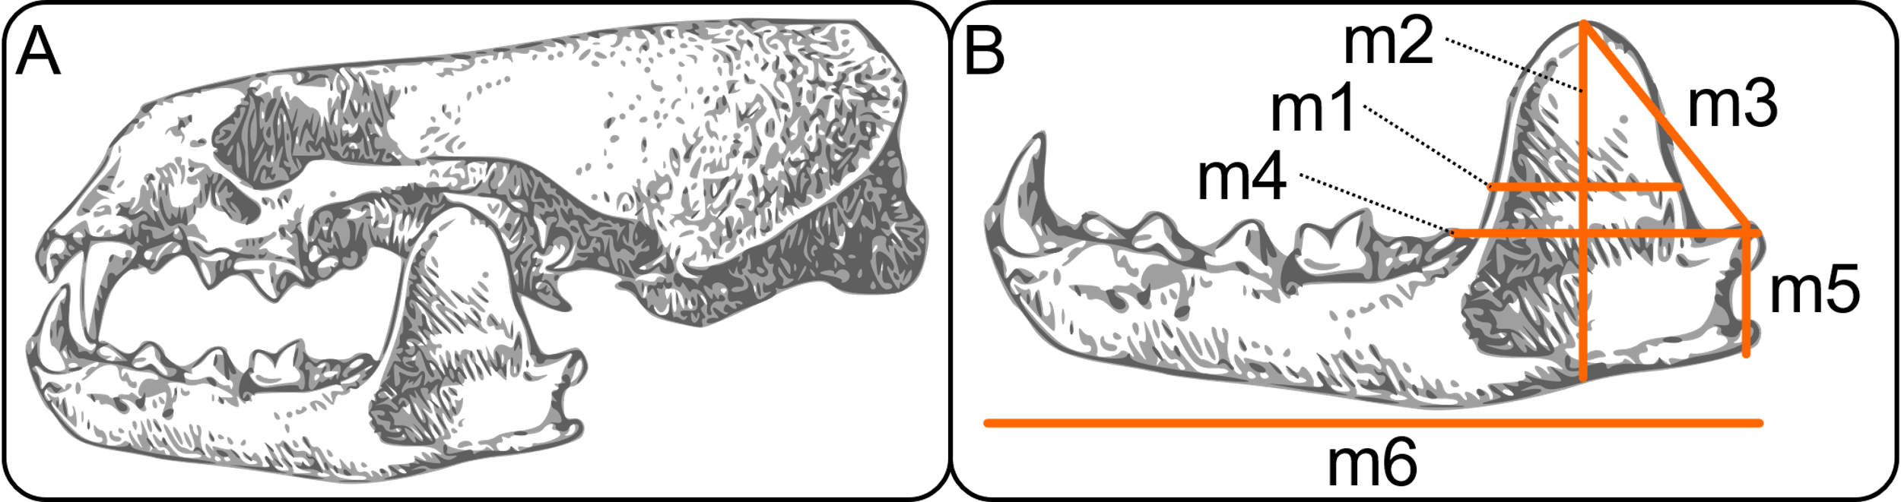
Perform a linear discriminant analysis to answer the following questions:

- How many linear discriminants should you consider?

- What are the singular values for each linear discriminant? What proportion of separate does each linear discriminant explain?

- If a mammal has mandibular ramus width of 13, mandibular ramus height of 30, moment arm temporalis of 21, out lever at carnassial of 10, moment arm masseter of 12, and jaw length of 60, in cm, which species should this mammal be classified as? Why? (Use the posterior probabilities to explain)

- Plot the data on the LD1-LD2 space (no need to attach the graph; show it in R Markdown), write down which species is clearly very different (far away) from the other three?

- Use the admission data from the University of Iowa on d2l, perform a linear discriminant analysis and answer the following questions:

- How many linear discriminants should you consider?

- What are the singular values for each linear discriminant? What proportion of separation does each linear discriminant explain?

- If a student with GPA of 2.0 and GMAT of 690, will that student likely be admitted? Use your posterior probabilities to explain.

- If a student with GPA of 3.8 and GMAT of 300, will that student likely be admitted? Use the posterior probabilities to explain.

- What if a student with GPA of 3.8 and GMAT of 550? Use the posterior probabilities to explain.

- Compare the above three questions, which score plays a more important role on admission

- Generate a plot to show the three groups (admitted, not admitted, and border) on the LD1-LD2 space (No need to attach the graph; Show it in R Markdown)

- Use the LEAD data on d2l to perform a linear discriminant analysis and answer the following questions. The other variables are Comprehension subtest IQ score (iqv_comp), Arithmetic subtest IQ score (iqv_ar), Digit span subtest IQ score (iqv_ds), Picture completion subtest IQ score (iqp_pc), Block design subtest IQ score (iqp_bd), Coding subtest IQ score (iqp_cod), Full IQ score (iqf) and lead group (Group with 1 meaning control group and 2 meaning exposed group). Consider Group as the only independent variable and the seven IQ variables mentioned above as the dependent variables.

- How many linear discriminants should you consider?

- If an indivi, iqv comp of 9, iqv ar of 2, iqv ds of 7, iqp pc of 10, iqp bd of 8, iqp cod of 20 and iqf of 90, which group should he be in? Why? (Use the posterior probabilities to explain)

- Use the Chest_Waist_Hips data to do a linear discriminant analysis and answer the following questions:
- How many linear discriminants should you consider?

- If a person has chest circumference of 39cm, waist of 30cm, and hip of 38cm, predict the gender of that individual. What are the posterior probabilities?

